Regina Pugh
AEA
reginapugh.weebly.com
reginapughaz@gmail.com

Height: 5'5 Hair: Brunette Eyes: Dark Brown

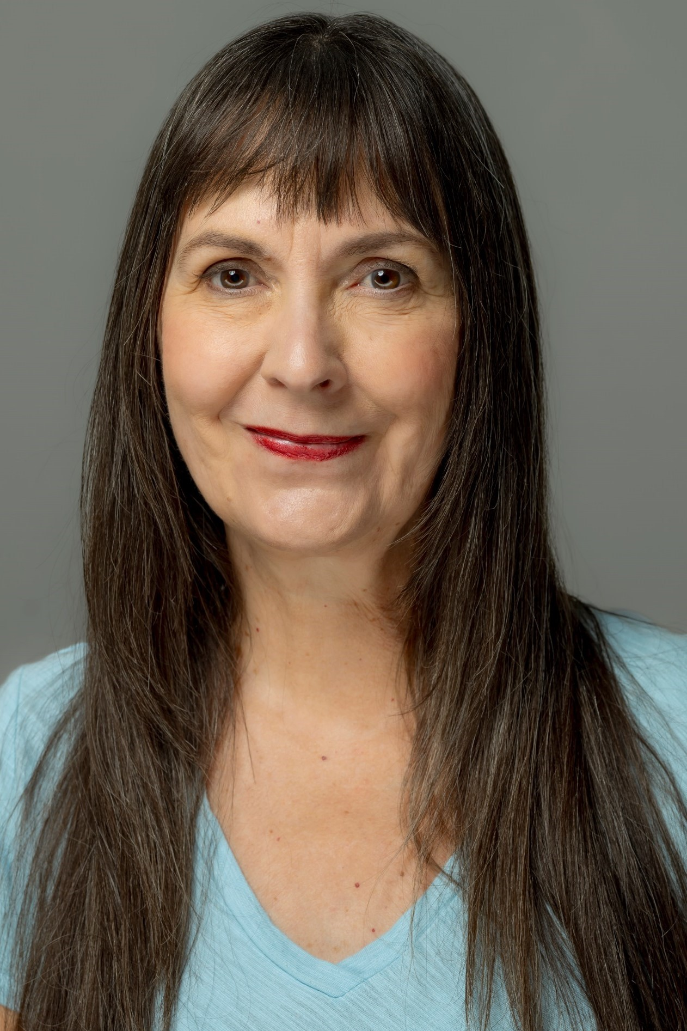

THE BOOK OF WILL Rebecca/Anne Phoenix Theatre Company Melissa Rain Anderson
THE GLASS MENAGERIE Amanda U/S Arizona Theatre Company Chanel Bragg
PIPELINE Laurie Ensemble Theatre Cincinnati Ron OJ Parson
ELEGIES FOR ANGELS… Charlotte, Et al. Ensemble Theatre Cincinnati Jared O’Roark
ANNAPURNA Emma Ensemble Theatre Cincinnati D. Lynn Meyers
THE OTHER PLACE Juliana Ensemble Theatre Cincinnati D. Lynn Meyers
NEXT FALL Arlene Ensemble Theatre Cincinnati D. Lynn Meyers
MY NAME IS ASHER LEV Woman Ensemble Theatre Cincinnati D. Lynn Meyers
FRAGMENTS Woman 2 Ensemble Theatre Cincinnati Edward Albee
AFTER THE FALL Holga Ensemble Theatre Cincinnati Rebecca Miller
EVERYTHING IN THE GARDEN Cynthia Ensemble Theatre Cincinnati Edward Albee
BUCKMINSTER FULLER Bucky #1 Ensemble Theatre Cincinnati Michael Burnham
THE WATER ENGINE Rita Ensemble Theatre Cincinnati David A. White
CHRONICLES OF PLAGUE Feral Girl Ensemble Theatre Cincinnati David A. White
A PARTY TO MURDER Henri Ensemble Theatre Cincinnati Douglas Hughes
A CHRISTMAS CAROL Mrs. Cratchit, Et al. Cincinnati Playhouse Michael Evan Haney
INVENTION FOR FATHERS & SONS Channele Cincinnati Playhouse Jay Raphael
FINAL PLACEMENT Luellen Cincinnati Playhouse Kim Osgood
BURIED CHILD Halie Xavier University Guest Artist Ed Stern
THE DIARY OF ANNE FRANK Edith Frank Cincinnati Shakespeare Jeremy Dubin
SENSE AND SENSIBILITY Mrs. Dashwood Cincinnati Shakespeare Drew Fracher
THE CRUCIBLE Rebecca Nurse Cincinnati Shakespeare Brian Isaac Phillips
SILENT SKY Williamina Know Theatre of Cincinnati Tamara Winters
HARVEY Veta Louise Carnegie Center (Covington, KY) Buz Davis
EQUUS Dora Strang New Edgecliff Theatre Alan Patrick Kenney
THE HISTORY BOYS Mrs. Lintott New Stage Collective Alan Patrick Kenney
THE MAIDS Claire Performance Gallery Brian Robertson
WAIT UNTIL DARK Susy Downtown Theatre Classics Mark Mocahabee
REQUIEM FOR A HEAVYWEIGHT Grace Frankenstein Project Robert Allen
BURY THE DEAD Mother CCM at The Carnegie Center Michael Burnham

Directing, Teaching, Film, Video, Commercial, Print and Voice-over credits available upon request.

M.F.A – Acting, Southern Illinois University at Carbondale Internship – Cincinnati Playhouse in the Park
Continuing Education- Pilobolus Summer Workshop, Workshops/Training in Michael Chekhov, Rasaboxes, Fitzmaurice, Simple Clown, Margolis, Physical Theatre, Anti-Racist Theatre

Basic skills in dance, stage combat and yoga.
Enjoys devising ensemble-based theatre pieces with twenty consecutive years of participation as a Producer/Actor/Director in Cincinnati Fringe Festival.

Works well with children and/or animals – preferably not both at same time but I can be persuaded.

